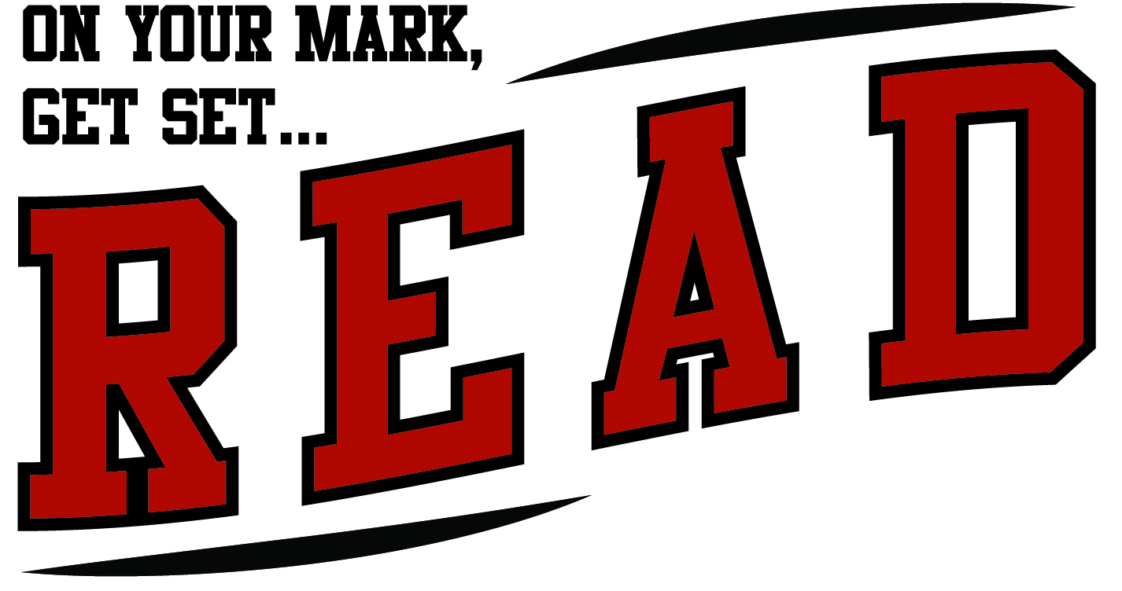
Belle Plaine Public Library
2016 Summer Reading Activities/Events

Fri. May 20th: Registration Opens!

JUNE:
Wed. June 1st: 10:00am First Day! Introduction and activities
Wed. June 8th: 10:00am Outdoor Jumping activities
Wed. June 15th: 10:00am Bicycle Rodeo - bring/ride your bikes!!
Fri. June 17th: 7:00pm TEEN: Mini-golf @ the Library
Tues. June 21st: 7:00pm ADULT: Mascots of Kansas Program
Wed. June 22nd: 10:00am Get Moving! activities
Wed. June 29th: 10:00am Oversized Games

JULY:
Wed. July 6th: 10:00am Sedgwick Co. Zoo Presentation
Fri. July 8th: 7:00pm TEEN: Iron Chef cooking and Movie Night
Wed. July 13th: 10:00am Healthy Eating Activities and snack
Tues. July 19th: 7:00pm ADULT: Beginner Yoga Class
Wed. July 20th: 10:00am Last Day! Surprise activities
FINAL CELEBRATION details will be announced soon

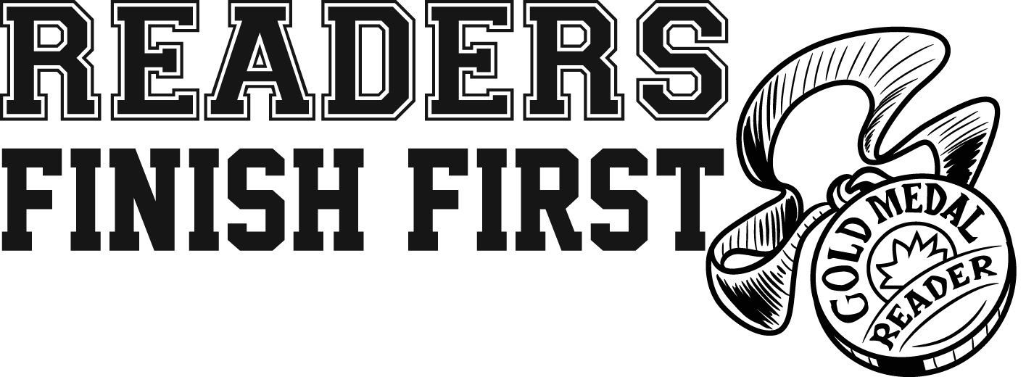
**More details, information and registration on Teen/Adult programs will be provided soon**

